Returning to Training
by Charlotte Charfen, October 2019

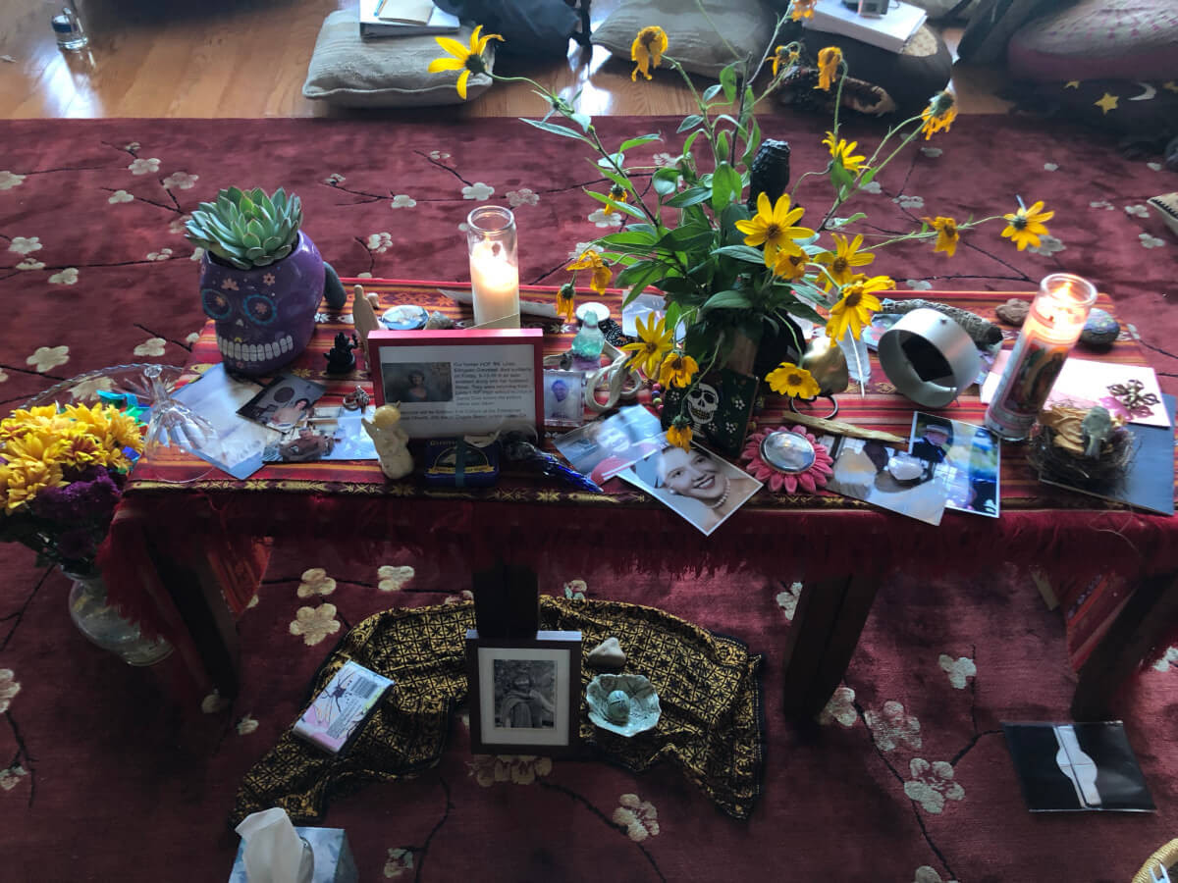
Night had brought much restless sleep. By the time dawn came, I had been awake for hours. It was all nerves. In the past, it would have been the excited kind: to be blessed with teaching a sold-out course to a group of end-of-life doula trainees. This time, it was fear and angst.
After suffering so many recent setbacks that culminated in my health almost being completely lost, I questioned everything I did in my life. Why was I expending my energy teaching a group of strangers? What was my motivation for traveling far from my safe haven in Hawaii to an unfamiliar town across the Pacific? Was I even capable of teaching anymore? What joy did life bring anyway? Certainly, there could be none in dying despite my numerous experiences to the contrary.
I was trembling and my stomach kept knotting. It wasn’t performance anxiety or the early morning chill. When I got real with myself, I knew exactly my biggest fear. What if this wild dream I had been so passionately following, to work and educate about Life and Death was just a delusion that my sick mind had created to give me some sense of purpose in a broken-ass world which really had no meaning.

My life as an ER doctor was so much easier than this unfamiliar path. I could do that job with my eyes closed, no matter how fragmented and traumatizing that system had become. And so, I did close my eyes.
As I held in my hand a feather that I had found on a quiet walk in the surrounding woods, I bowed my head and I said a prayer. On my Paw’s deathbed, I had asked for a sign and had immediately heard a crazy bird noise outside his window. I presumed he was calling me cuckoo even while he was dying. The feather felt like a perfect, simple tribute to him from nature, which I planned to place on our group altar, created to honor all our deceased loved ones.
Praying, breathing, and asking for guidance as I held the feather, the constricting band loosened a little. When I opened my eyes, a large doe was staring at me through my bedroom window, so close I could see her eyelashes. “Rhonda?” I whispered. Deer had always been her sign from the other side. She had been the one that started this whole mystical death journey for me.
Now here they both were, father and daughter, both deceased but together in spirit and supporting me once again along this bizarre expedition of life and death. Or maybe I was just crazy. No matter, the time had come to commence our voyage and so the training began.
Twenty women circled together. I could feel their nervous wonder, gratitude, and excitement on embarking into an education most people still didn’t understand existed, much less could explain. And then, I could feel myself transform as soon as I clasped hands. These were not strangers. They were my sisters. They ranged from young adults to elders. Each apprentice already embodied wisdom, love, and a devotion of service to themselves, their community, and humanity. All had been touched and transformed in some form by the depth, the beauty, and the sacred of living and dying. They understood that the two were not separate. And they were all hungry to go deeper and learn more collectively, for their own personal lives and for the betterment of others.
Each end-of-life doula training that I have co-facilitated is always unique. However, each time there have been tears, pain, traumas, sadness, depth, and sacred engagement. Many wonder why the hell would someone sign up and pay for such a thing? And why would I care to teach it? My answer would be because of the love, connection, laughter, joy, and empowerment that also continually occurs. Somewhere in my own grief, I had temporarily forgotten.
It took a student compliment — that I needed my own death stand-up comedy show — to jolt me back into the reality that the human condition can be quite hilarious, and dare I say fun, even when it comes to topics of death and disease.

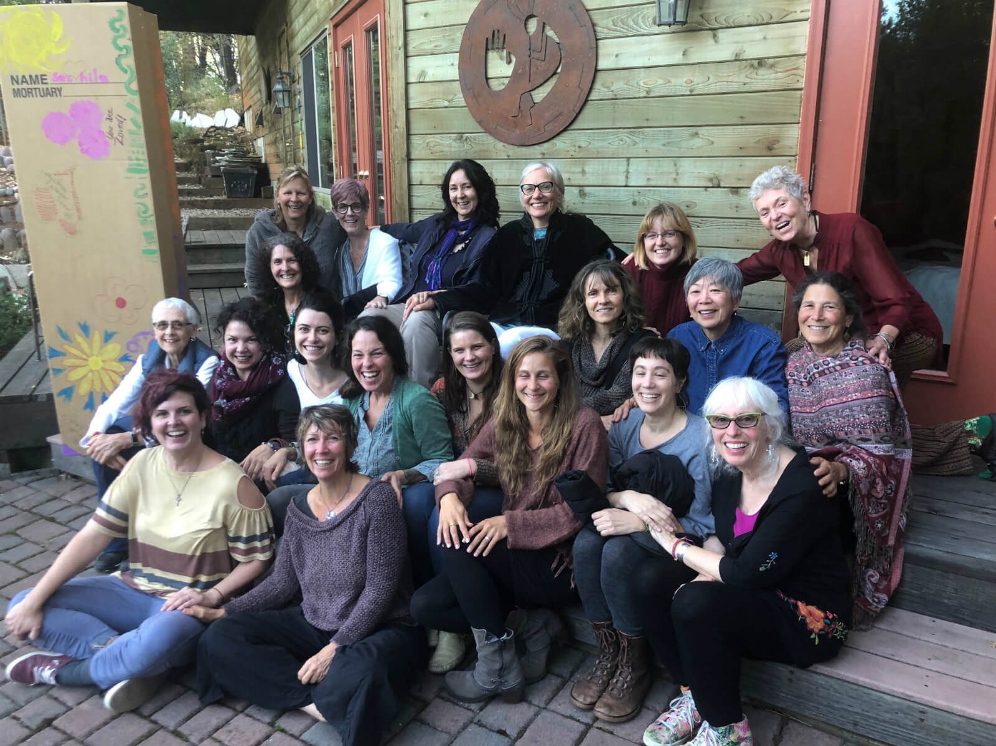
Fun, that is, unless you are attending my first lecture. That one is quite depressing. It focuses on the crisis of end-of-life care in America and across much of the world. But I always end this talk with hope and optimism, simply because I am able to look out at a room full of trailblazers who are already creating change within and outside of our broken systems. Beautiful human beings who are willing to remember and practice the ancient wisdom of caring for each other and our globe, not only from birth but through life and death.
I am in utter and absolute gratitude to the women of the Grass Valley End-of-Life Doula training, for confirming that pure bliss is always there when you follow your calling, no matter how cuckoo it may seem, sound, or even feel. This doctor needed reviving. Thank you for reminding me of the meaning of life and death in all our perfect collective cracks and brokenness.
It is all Love.

“For me, living is the same thing as dying, and loving is the same thing as losing, and this does not make me a madwoman; I believe it can make me better at living and better at loving, and, just possibly, better at seeing.” – Sally Mann

